Invitation to your school, to attend a FREE Schools Science taster session at the United Kingdom Radiological Congress (UKRC)
To be held at the ACC, Liverpool, on Wednesday 1 July 2015, 14:00 -16:00pm
Following the great success and excellent feedback from 2014, we are delighted to once again extend an invitation to secondary school students, ages 13-14, from the Liverpool area to attend a FREE schools science taster session - to enable students to experience and learn about the basics of radiological science.

Benefits of attending
Exciting, interactive and hands-on sessions for young people to experience and learn about the basics of radiological science. Featuring demonstrations from the ‘Big Bang’ Show and much more, it is set to be a highly interactive afternoon, to enthuse students to increase their interest in science and specifically in medical applications. We also provide a learning and careers pack, useful to both teachers and students to take away.

Don’t just take our word for it….
View photos and see our short video to see what students and teachers who previously attended in Liverpool thought of the taster session!
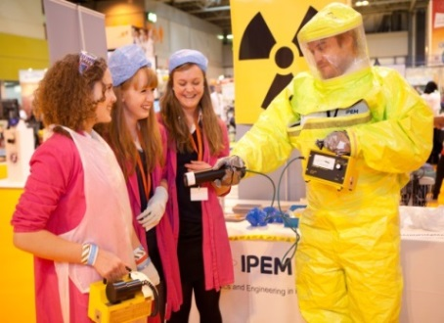
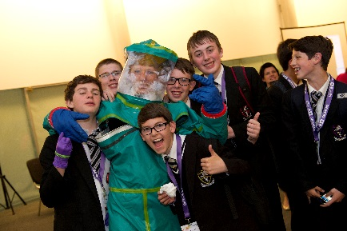
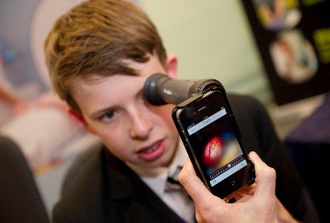

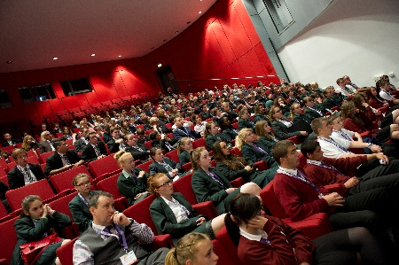

Programme of activities
13:30-14:00 Arrival & welcome to students
14:00-14:40 Interactive radiation lecture
A unique and interactive lecture on radiation with a quiz,
assisted by Homer Simpson, stress balls, torches and sheets! Supported by SRP and ROC

14:45 -15:45 Demonstrations, activities and competition session
“Big Bang” style table top demonstrations of approximately 15 minutes.

16:00 Thanks and depart

To register your interest
Places are limited, please register your interest to ali@merseystem.co.uk by stating:

1) School name, a main contact name and email address.
2) How many students you would like to bring.
3) Date you will be able to provide a confirmed list of student names.

Terms: Final confirmations of places and numbers per school are confirmed by the Conference Organisers, Profile Productions by email and places per school may be limited. We may also ask to conduct interviews with some students, so we will require parental agreements to be in place prior to the event.

