STEM Insight Employer Pledge
Insight into industry is a unique opportunity for employers to provide a stimulating experience for teachers, lecturers, managers and technicians of STEM subjects to update their knowledge and awareness of modern STEM related careers.

Employers provide a placement (typically 5 days), that will provide opportunity for teachers to see working life across the business.

Eligible schools and colleges will receive generous funding to participate through Project ENTHUSE.

Why offer placements?
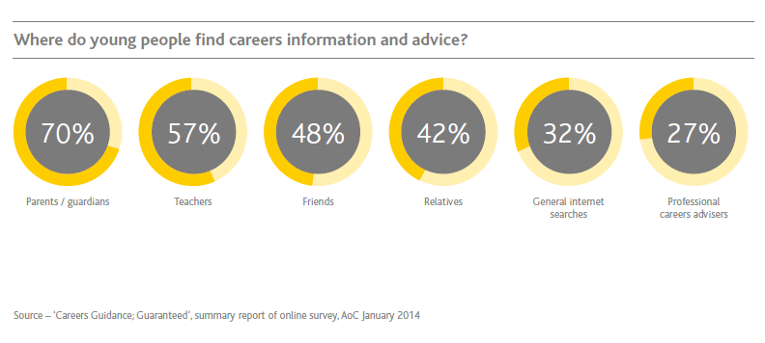
Recent studies have shown that teachers are one of the most important influences on a students’ career choice. We believe that by giving teachers an authentic experience of industry, they will have the increased experience and confidence needed to better advise their students.

How can employers help?
We are looking for employers in England, Scotland, Wales and Northern Ireland to pledge that they will host a STEM Insight placement. All pledges will be held on the STEM Insight site allowing school and college staff to browse and find a placement near to them.

By submitting a pledge, you are offering to support at least one school or college to better understand the careers available to their students, through spending a 5 day placement within your business. The dates for your placement will be mutually agreed, once a school or college has applied to work with you. Applications from schools and colleges will be made through the STEM Insight site. A member of the STEM Insight team will contact you when an application has been received to discuss the next steps and support you with arranging your placement

What does a placement involve?
STEM Insight placements can be flexible depending on the type of activity that your business is involved in. The start of your placement should involve an induction of your site and orientation of what work you are involved in. The subsequent days should be arranged to give as wider experience of your business and the staff working there as possible. Good placements generally offer a chance to be hands-on and get involved, but in some cases, we understand that this is not possible. Once an application is received, a member of the STEM Insight team will be assigned to you to advise and help develop your placement timetable.

Please return this completed form to insight@stem.org.uk with the subject line:
[employer name] pledge form

Employer details
Name of company:
Location of placement (full address please):
Contact 1 (lead contact)
Name:
Role:
Email:
Phone number:
Contact 2 (if lead contact 1 is unavailable)
Name:
Role:
Email:
Phone number:
Placement information
Are there any dates that we should avoid placing a teacher with you?
The Company agrees that there is adequate Public Liability Insurance in place to cover any liability incurred by the teacher during their placement (You will be asked to provide evidence of this prior to a placement taking place) | .
Security arrangements. (Are there are security documents that need to be provided before the participant can enter site.)
What does your organisation do?
Please provide a brief description in addition to relevant weblinks
What types of activities / areas / projects will a teacher be able experience during your placement?
Are you involved in any projects that a teacher might find interesting?
We often use projects as examples when advertising placements on our website.

Signed on behalf of the Company:

Signed: ……………………………………………………

Print Name: …………………………………………………………………… Date: ……………………

Role:…………………………………………………… Contact email:…………………………………

